Localization System on Wheel Robot Soccer

Yoga Pratama1, Hendawan Sobeakti2, Senanjung Prayoga3, and B.Budiana4

{yogypr03@gmail.com1, [hendawan@polibatam.ac.id2](mailto:hendawan@polibatam.ac.id2), [senanjung@polibatam.ac.id](mailto:senanjung@polibatam.ac.id)3, budiana@polibatam.ac.id4}

Department of Electrical Enggineering, Politeknik Negeri Batam, Batam, Indonesia

**Abstract.** Wheeled robot soccer is a robot designed to play soccer. In Fact, the robot must be able to play like humans in wheeled robot soccer competition. The wheeled robot soccer is divided into several parts such as striker robot, defender robot and kipper robot. The striker robot is a robot that has the task of being able to score goals against the opponent's goal and the defender robot has the task of guarding the defense area. While the kipper robot is to guard the goal so that gold does not enter the goal. The positioning of robot is one of the most important things in the manufacture of automatic robots. Robots had to know their position and the opponent robot position . One way to find out how far the robot moves is by using a rotary encoder equipped with a gyroscope. Nevertheless, this method is easily affected by the environment like slips condition. As a result of slip, error position will be generated. Furthermore, the camera mounted on the robot is needed to correct erorr position

**Keywords:** Particle Filter, Localization, Forward Kinematic, and midle Size League

1 Introduction

Barelang 63 robot has three robots (two attacker robots and one goalkeeper robot). The Attacker robots have the task of scoring goals into the opponent’s goal, while the goal keeper robot serves as a goalkeeper from the opponent’s attacker. In fact, BARELANG 63 Robotics Team have a localization system that can determine the position of its own robot [1] and the opponent’s robot. Nevertheles, robot positioning is the main problem on automatics robots. If the robot does not know the position of the robot itself, it will be difficult to determine futher action. In wheeled robot soccer, robots position localization generally using a rotary encoder [1] to get the rotational speed of each wheel, and a Gyroscope sensor to determine the direction of the robot. The value of rotary encoder speed and the direction of robot using Gyroscope can be processed using the forward kinematic method. As a result, the global [2] robots position can obtained.

When the robot moves and changes position in its environment, the measured position sometimes differs from the actual position. This condition is caused by footbal pitch. The use of a rotary encoder, for example, will have the potential for slippage due to uneven or slippery floor surfaces. If the condition continues over time, it will cause a difference between the measured position and the actual position. As a consequence, the measurenment which undertaken was not precise.

The wheeled robot soccer must know the position of itself and the opponent so that the further movement planning becomes more efficient. One way that can overcome error position is camera equipped with sensor [3]. The camera on the robot can be used to determine the position of the robot against the field by detecting landmarks/signs. In addition, the landmark position was already known. Furthermore, the position of the robot can be determined using the particle filter localization method. By using a rotary encoder and camera as a correction, accurate localization can be obtained.

In this research, a robot positioning system was designed by utilizing the forward kinematic system on a robot that uses a rotary encoder and Gyroscope whose values can be updated and corrected from the results of image processing from the camera.

2 Methode

2.1 Object Detection

The method which was used to detect an object on a wheeled soccer field was YOLO. This method was used on robots because the robot requires a detection system that had a fairly high level of accuracy and was able to work in various light conditions. Apart from that, This methode [4] uses a Deep Learning system which can learn an object or case by itself.

Deep Learning was also known as Deep Neural Network which able to operate and manage large amounts of data because it used many layers [5] (network layers). Yet, the YOLO method, training and detection [7], feature extraction and regression classification, were all done in one network. YOLO regard object detection as a regression problem. Once the image [6] was input into the network, the position of all objects in the image, their categories and corresponding confidence probabilities can be obtained.

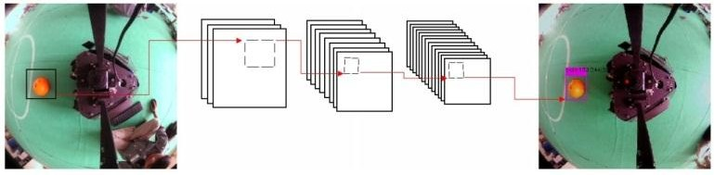

**Fig. 1**. YOLO Object Detection [5]

### 2.2 Forward Kinematic

Forward Kinematic [1] is a matrix formula that determines the position and direction of the robot when it moves and is designed with a configuration like **Fig.2** which shows the installation position of three symmetrical omnis. The omni position which is installed symmetrically makes the center of mass located at the center point of the robot. Position a1() = 180­o, a2 () = 300o, a3 () = 60o. To get the desired movement can be calculated using the jacobian matrix equation, with the calculation of the forward movement:

(3)

With :

= Speed on the x-axis (cm per second)

= Speed on the y-axis (cm per second)

= Robot's angular speed (radians per second)

R = Robot Wheel Radius (cm)

L = Distance from center of robot to center of wheel

= Wheel rotation speed (rotations per second)

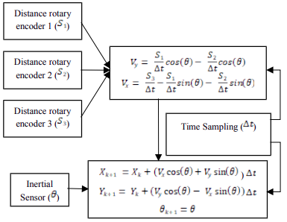

**Fig. 2**. Block Diagram Forward Kinematic [3]

### 2.3 Particle Filter

Particle filter is part of Bayesian filtering whose estimated value is based on the Monte Carlo method. Particle Filter aims to evaluate the posterior probability density function (PDF). Particle filters rely on a sample-based representation of PDF states or landmarks. Several samples (particles) of the resulting state, each associated with a weight that characterizes the quality of a particular particle. Variable estimates obtained by adding up the particles of all particles. The resampling stage selects the sampled particles based on their weight, where the particles are multiplied according to the size of the weight and finally the particles with low weight are likely to be selected. While the high weight will have the opportunity to be replicated repeatedly. In other words, the output of the resampling [7] stage is the particles that are concentrated in the region that has the highest probability. The Particle Filter Algorithm is shown in **Fig.3.**

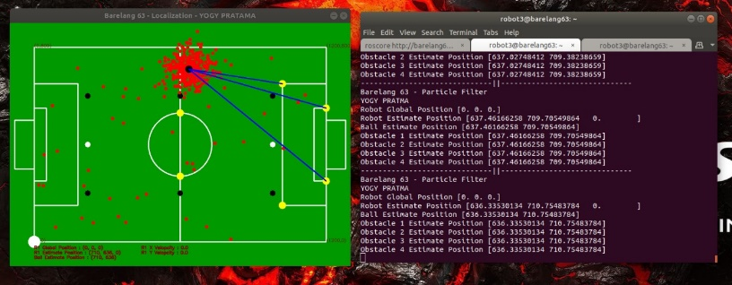

**Fig. 3.** Particle Filter Visualization

### 2.4 Fusion Camera & Odometry

In this study, the Particle Filter method is used as a robot position correction.

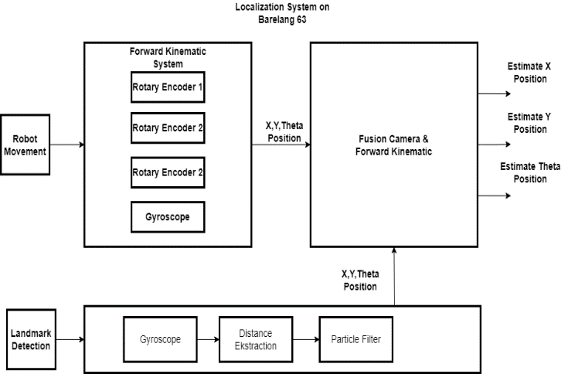

**Fig. 4.** Data Fusion Charts

In **Fig.4**, we can see that the robot requires a rotary encoder as input so that the robot can find out where it is, the rotary encoder will generate pulses where the pulses can be converted into RPS (Rotation Per Second), from the results of the rotation it can be processed. using the forward kinematic method, the local coordinates of the robot will be converted using a rotation matrix in order to know the coordinates of the robot globally. we can see that updating the position of the robot using the camera [10] was carried out using a feature that can determine the distance of each detected landmark in accordance with the coordinates of the field markings that have been detected by YOLO. The known landmark distances [5] can be processed using the particle filter method in order to find out the actual estimated position of the robot (**Fig.5**).

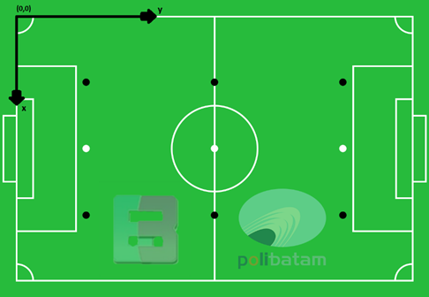

**Fig. 5.** Wheeled Football Robot Field Illustration

3 Experiment Result

3.1 Origin To Point Rotary Encoder Test

In this test, it was used to determine the distance traveled by the robot and the coordinates of the robot's position from the origin (0,0) to a certain point so as to produce the data in **Table 1**.

**Table 1.** Rotary Encoder test origin to point.

|  |  |  |  |  |  |  |
| --- | --- | --- | --- | --- | --- | --- |
| No | Destination Pos | | Forward Kinematic | | Error | |
| X  (cm) | Y  (cm) | X  (cm) | Y  (cm) | X  (cm) | Y  (cm) |
| 1 | 100 | 600 | 103 | 585 | 3 | 15 |
| 2 | 200 | 600 | 215 | 580 | 15 | 20 |
| 3 | 270 | 600 | 286 | 580 | 16 | 20 |
| 4 | 400 | 600 | 401 | 578 | 1 | 22 |
| 5 | 530 | 600 | 523 | 577 | 7 | 23 |
| 6 | 600 | 600 | 596 | 576 | 4 | 24 |
| RMSE (˚) | | | | | 13.26 | 20.97 |

**Table 1**, the Origin To Point Rotary Encoder Test obtained the Root Mean Square Error (RMSE) value at the X value of 13.26 cm and Y of 20.97 cm.

## 3.2 Point To Point Rotary Encoder Test

The test was carried out by changing the position of the robot from the previous point position to a certain point and then proceeding to another point by placing the robot at points in the field whose actual position was known as shown in **Fig.6.**

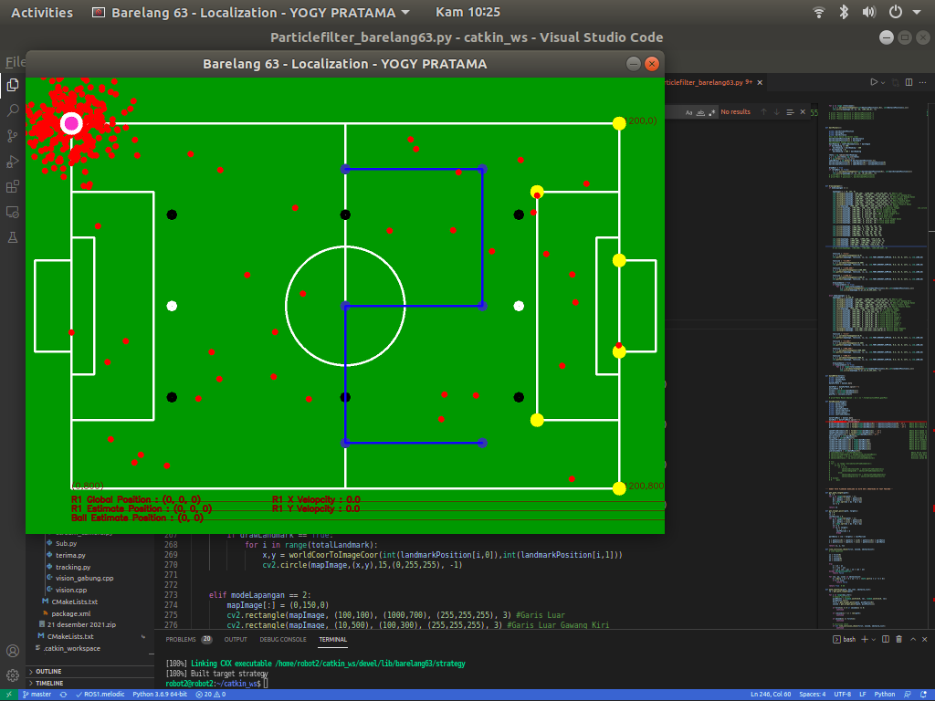

**Fig. 6**. Point to Point Testing Point

**Table 2.** RE and GY result point to point .

|  |  |  |  |  |  |  |  |  |  |
| --- | --- | --- | --- | --- | --- | --- | --- | --- | --- |
| No | Destination Pos | | | Forward Kinematic | | | Error | | |
| X  cm | Y  cm | Theta  deg | X  cm | Y  cm | Theta  deg | X  cm | Y  cm | Theta  deg |
| 1 | 0 | 600 | 0 | 0 | 600 | 358 | 0 | 0 | 2 |
| 2 | 100 | 600 | 0 | 105 | 604 | 355 | 5 | 4 | 5 |
| 3 | 100 | 900 | 0 | 109 | 898 | 354 | 2 | 2 | 6 |
| 4 | 400 | 900 | 0 | 389 | 904 | 353 | 11 | 4 | 7 |
| 5 | 400 | 600 | 0 | 403 | 609 | 356 | 3 | 9 | 4 |
| 6 | 700 | 600 | 0 | 703 | 618 | 354 | 3 | 18 | 6 |
| 7 | 700 | 900 | 0 | 688 | 917 | 356 | 12 | 17 | 4 |
| **RMSE** | | | | | | | 6.67 | 10.21 | 5.099 |

.

From the data above with the robot facing 0˚, the RMSE results are 6.67 cm on the x-axis and 10.21 cm on the y-axis.

## 3.3 Mesurement of Landmark Distance to Robot

In this detection system, the objects used for localization were the goal [12], the edge of the penalty box and the corner. Before testing the robot's position measurement using a camera, it was necessary to know in advance the distance that can be measured by the camera as shown in **Fig. 7.**

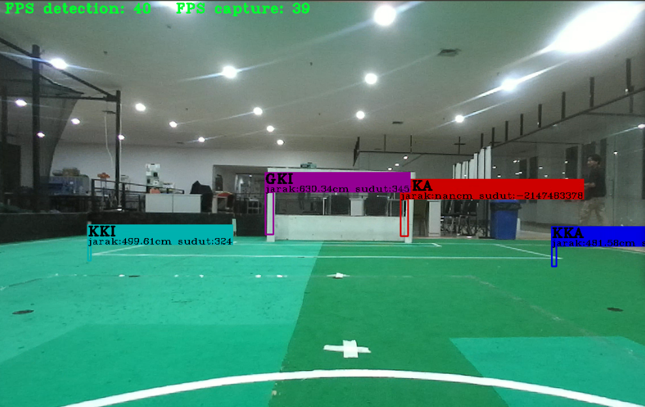

**Fig. 7**. Landmark Distance Measurement with Camera

**Table 3.** Landmark Actual Distance

|  |  |  |  |  |  |  |
| --- | --- | --- | --- | --- | --- | --- |
| Pos | Actual Distance(cm) | | | | | |
| CKI | CKA | KKI | KKA | GKI | GKA |
| A | 600 | 0 | 420 | 0 | 610 | 710 |
| B | 300 | 0 | 120 | 0 | 350 | 0 |
| C | 0 | 0 | 0 | 0 | 310 | 310 |
| D | 0 | 0 | 500 | 500 | 600 | 600 |

**Table 4.** Landmark Distance Measured

|  |  |  |  |  |  |  |
| --- | --- | --- | --- | --- | --- | --- |
| Pos | Distance Measured(cm) | | | | | |
| CKI | CKA | KKI | KKA | GKI | GKA |
| A | 580.2 | 0 | 442.2 | 0 | 576.158 | 716.4 |
| B | 298.4 | 0 | 144.5 | 0 | 315.4 | 0 |
| C | 0 | 0 | 0 | 0 | 310.4 | 307.5 |
| D | 0 | 0 | 518.93 | 504.2 | 609.2 | 592.8 |

**Table 5.** Landmark Eror

|  |  |  |  |  |  |  |
| --- | --- | --- | --- | --- | --- | --- |
| Pos | Error (cm) | | | | | |
| CKI | CKA | KKI | KKA | GKI | GKA |
| A | 19.8 | 0 | 22.2 | 0 | 33.84 | 6.4 |
| B | 1.6 | 0 | 24.5 | 0 | 34.6 | 0 |
| C | 0 | 0 | 0 | 0 | 0.4 | 2.5 |
| D | 0 | 0 | 18.93 | 4.2 | 9.2 | 7.2 |

With:

* *CKI* : *Left Corner*
* *CKA* : *Right Corner*
* *KKI*  : Left Penalty Box
* *KKA* :Right Penalty Box
* *GKI* : Left Goal
* *GKA* : Right Goal

The following was **Table 3-5** which was the result of measuring the distance of the landmark with the robot. From the results of measuring the distance of the landmark in table 8, it will be input for the particle filter which will be processed into the global position of the robot. The test was carried out by shifting the robot to several points that have been determined by **Fig.7**. From the measurement results, it was obtained that the Root Mean Square Error (RMSE) data was 8.10 cm for the Left Corner, 1.60 cm for the Right Corner, and 15.50 cm for the Right Corner. Left Penalty Box, 2.14 cm for Right Penalty Box, 29.9 cm for Left Goal and 19.23 cm for right goal. This error was affected by the distance measurement accuracy of the ZED Camera.

## 3.4 Robot Estimate Position Test

The test was carried out by placing the robot at points in the field whose actual position was known, then measuring the distance between the robot and the landmark and the particle filter process will result in the x and y positions of the robot with respect to the field.

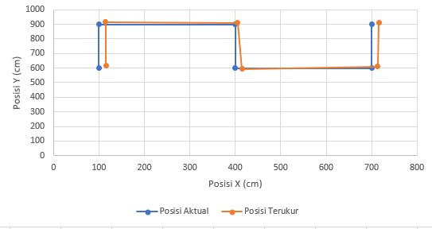

**Fig. 8**. Robot Estimate Position Graph

**Table 6.** Robot Estimate position test with camera.

|  |  |  |  |  |  |  |
| --- | --- | --- | --- | --- | --- | --- |
| No | Actual Pos (cm) | | Estimate Pos With Camera | | Error | |
| X | Y | X | Y | X | Y |
| **1** | 100 | 600 | 115.63 | 618.12 | 15.63 | 18.12 |
| **2** | 100 | 900 | 114.47 | 914.42 | 14.47 | 14.42 |
| **3** | 400 | 900 | 404.95 | 908.67 | 4.95 | 8.67 |
| **4** | 400 | 600 | 414.43 | 593.07 | 14.43 | 6.93 |
| **5** | 700 | 600 | 713.36 | 610.24 | 13.36 | 10.24 |
| **6** | 700 | 900 | 715.88 | 912.85 | 15.88 | 12.85 |
| **RMSE (˚)** | | | | | 13.64 | 12.44 |

The Root Mean Square Error (RMSE) obtained was 13.64 cm on the x-axis and 12.44 cm on the y-axis. This value can still be tolerated when compared to the size of the robot, which was 50 x 50 cm². Based on observations, the positioning of the robot with this camera was very sensitive because if the distance measurement at the landmark has a large error, the position processed by the particle filter will also have a large error.

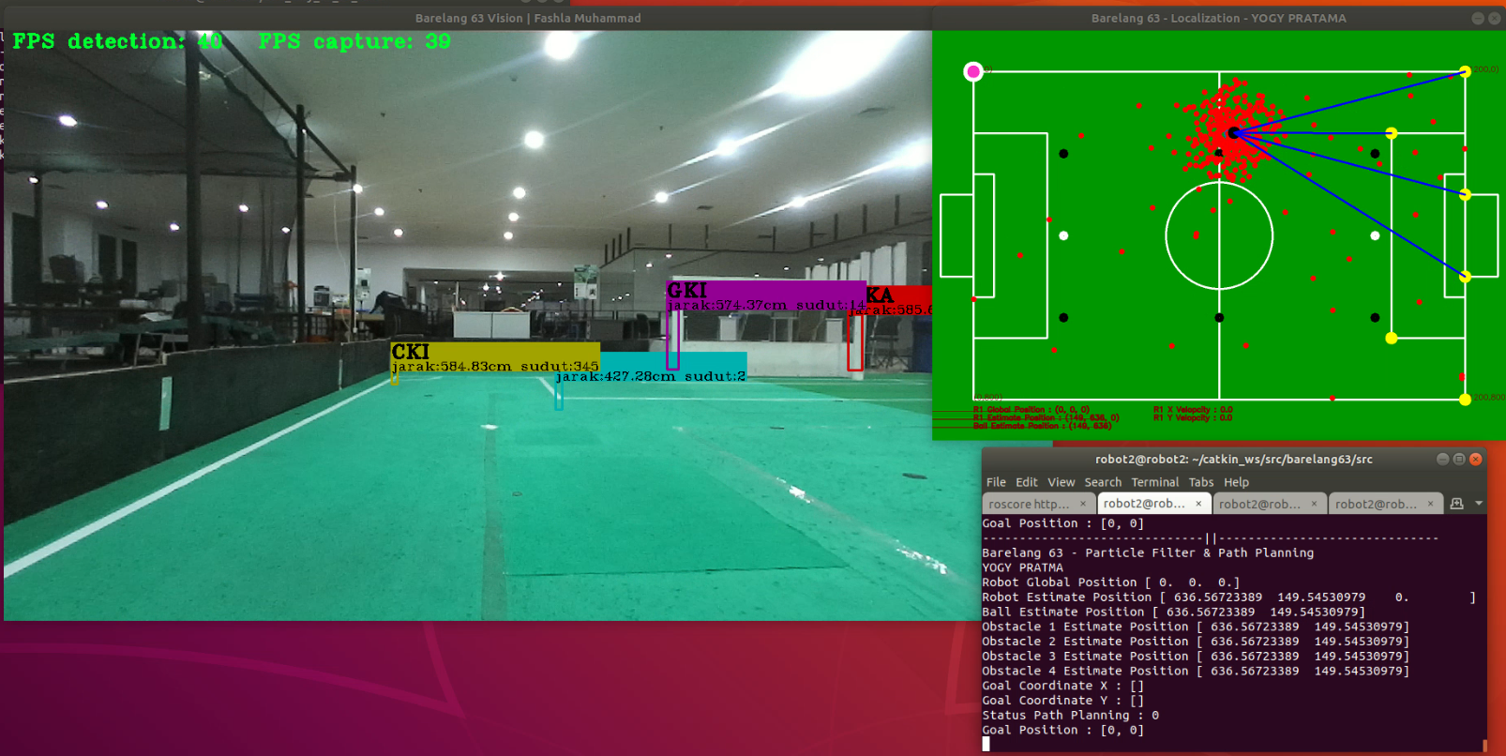

**Fig. 9**. Estimate Poisition With Camera

## Conclusion

Based on the tests that was carried out in the previous chapter, the object detection system (YOLO) was able to detect, measure the distance of all objects that was set by the author. The detection system had an mAP percentage of 95.99% for the six objects that can be detected. For distance measurement, it was done by placing the object in front of a stereo camera at a distance of 1 meter to 10 meters, then compared with manual measurements using a meter. For distance measurement, the RMS error was 8.10 cm for the left corner, 1.61 cm in the right corner, 15.5 cm in the left penalty box, 2.14 cm in the right penalty box, 29 in the left goal, 9 cm, and 19.23 cm on the right goal. The update of the robot's position will be carried out if the robot receives data from the base station that the game was stopped or paused. When the robot receives a stop or pause command, the robot will face an angle of 0˚ after that the robot will update the position by looking at the landmark that was being detected, then the results of the positioning error by the Rotary Encoder and Gyroscope will be updated with the calculated position using a particle filter. Based on the tests carried out in the previous chapter, when the robot knows its position globally, the distance and angle of the object, the distance and angle of the object detected by the robot can be calculated using the rotation matrix equation. In this test, an RMS error of 32.78 cm was generated for the x-axis and 20.31 cm for the y-axis.

## References

|  |  |
| --- | --- |
| [1] | G. E., A. J. M., G. D. S. P. and M. Armada, "The evolution of robotics research," *IEEE Robotics & Automation Magazine,* pp. 90-103, 2007. |
| [2] | R. Afriza, Position Control Pada Mobile Robot Omni Directional Wheel Kiwi Drive Menggunakan Persamaan Inverse Dengan Feedback Forward Kinematic Berbasis PID, Batam, 2015. |
| [3] | Z. T. Romadon, H. Oktavianto, I. K. Wibowo, B. S. B. Dewantara, E. A. Nurrohmah and R. A. Priambudi, "Pose Estimation on Soccer Robot using Data Fusion from Encoders, Inertial Sensor, and Image Data," *2019 International Electronics Symposium (IES),* pp. 454-459, 2019. |
| [4] | A. Rachmawan, Penentuan Posisi Robot Sepak Bola Beroda Menggunakan Rotary Encoder Dan Kamera, Surabaya: Institut Teknologi Sepuluh Nopember, 2017. |
| [5] | H. Soebhakti, S. Prayoga, R. A. Fatekha and M. B. Fashla, "The Real-Time Object Detection System on Mobile Soccer Robot using YOLO v3," *2019 2nd International Conference on Applied Engineering (ICAE),* pp. 1-6, 2019. |
| [6] | J. Redmon, S. Divvala, R. Girshick and A. Farhadi, "You Only Look Once: Unified, Real-Time Object Detection," *2016 IEEE Conference on Computer Vision and Pattern Recognition (CVPR),* pp. 779-788, 2016. |
| [7] | H. Mandala, E. R. Jamzuri and H. Soebhakti, "Sistem Deteksi Bola Berdasarkan Warna Bola Dan Background Warna Lapangan Pada Robot Barelang FC," *Semin. Nas. Apl. Teknol. Inf,* pp. 14-20, 2016. |
| [8] | G. K. Heryanto, Image Based Inspection Machine, 2018. |
| [9] | J. Silva, N. Lau and A. J. R. Neves, "Cooperative detection and identiﬁcation of obstacles in a roboticsoccer team," *dalam Advances in ,* pp. 3-5, 2014. |
| [10] | U. B. Gohatre and V. P. Patil, "Estimation of velocity and distance measurement for projectile trajectory prediction of 2D image and 3D graph in real time system," *2017 International Conference on Energy, Communication, Data Analytics and Soft Computing (ICECDS),* pp. 2543-2546, 2017. |
| [11] | J. G. M., "Inertial Sensors, GPS, and Odometry," *dalam Springer Handbook of Robotics,* pp. 447-490, 2008. |
| [12] | S. Thrun, W. Burgard and D. Fox, Probabilistic Robotics, Cambaridge: MIT, 2005. |
| [13] | K. Adi and C. E. Widodo, "Distance Measurement With a Stereo Camera," *International Journal of Innovative Research in Advanced Engineering (IJIRAE),* pp. 24-27, 2017. |
| [14] | B. Sugandi, S. Prayoga, I. A. Riandi and D. G. Tinambunan, "Goal Detection and Opponent Avoidance Algorithm for Wheeled Robot Soccer using Color Filtering and Contour Extraction," *2018 International Conference on Applied Engineering (ICAE),* pp. 1-5, 2018. |